|  |  |
| --- | --- |
| **S.no** | **Index** |
| 1 | Problem Analysis and Project Planning for Student Mark Analysis System |
| 2 | Requirement Analysis for Student Mark Analysis System |
| 3 | Design for Student Mark Analysis System |
| 4 | Implementation for Student Mark Analysis System |
| 5 | Write manual test cases for Student Mark Analysis System |
| 6 | Problem Analysis and Project Planning for Payroll Processing System |
| 7 | Requirement Analysis for Payroll Processing System |
| 8 | Design for Payroll Processing System |
| 9 | Implementation for Payroll Processing System |
| 10 | Write manual test cases for Payroll Processing System |

**Program 1: Problem Analysis and Project Planning for Student Mark Analysis System**

#### AIM

To write ProblemAnalysis and Project Planning for Student Mark Analysis System

**PROCEDURE**

**Problem Analysis**

**Introduction**

Student mark analysis system has been designed to carry out the mark analysis process in an education institution. The result of each student of the respective departments can be efficiently computed without much of manual involvement.

**Objective**

The process of the system is defining the requirements of mark analysis system. This system reduces the manual work to great more analysis is carried out by the system is an efficient system.

**Scope**

The system is very essential for every education institutions as it reduces man power. The system can be used for all type of educational institution to evaluate and analyze mark and generate reports of specified criteria.

**Problem Statement**

Analysis the mark obtained by the student in an educational institution be developed student mark analysis system. This is done to replace the manual processing of mark. This system also maintains all information about the students.

The system will have a windows based desktop interface to allow the faculty to enter marks obtained by the student, update then and generate various reports.

For security reasons the administrator and faculty only can update the marks and other information.

#### Project Plan 3.Gantt chart

|  |  |  |  |  |  |  |  |  |  |  |  |  |  |  |  |  |  |  |  |  |  |  |  |  |  |  |  |  |  |  |  |  |  |  |  |  |  |  |  |  |  |  |  |  |  |  |  |  |  |  |  |  |  |  |  |  |  |  |
| --- | --- | --- | --- | --- | --- | --- | --- | --- | --- | --- | --- | --- | --- | --- | --- | --- | --- | --- | --- | --- | --- | --- | --- | --- | --- | --- | --- | --- | --- | --- | --- | --- | --- | --- | --- | --- | --- | --- | --- | --- | --- | --- | --- | --- | --- | --- | --- | --- | --- | --- | --- | --- | --- | --- | --- | --- | --- | --- |
| *ID* | *Task Name* | *Start* | *Finish* | *Duration* |  | | | *Dec 8 2019* | | | | | | | *Dec 15 2019* | | | | | | | *Dec 22 2019* | | | | | | | *Dec 29 2019* | | | | | | | *Jan 5 2020* | | | | | | | *Jan 12 2020* | | | | | | | *Jan 19 2020* | | | | | | |  | |
| *5* | *6* | *7* | *8* | *9* | *10* | *11* | *12* | *13* | *14* | *15* | *16* | *17* | *18* | *19* | *20* | *21* | *22* | *23* | *24* | *25* | *26* | *27* | *28* | *29* | *30* | *31* | *1* | *2* | *3* | *4* | *5* | *6* | *7* | *8* | *9* | *10* | *11* | *12* | *13* | *14* | *15* | *16* | *17* | *18* | *19* | *20* | *21* | *22* | *23* | *24* | *25* | *26* |
| 1 | Problem Analysis and Project Planning | 12/6/2019 | 12/13/2019 | 1w 1d |  |  | | | | | | | |  | |  | | | | |  | |  | | | | |  | |  | | | | |  | |  | | | | |  | |  | | | | |  | |  | | | | |  | | |
|  |  | |  | | | | |
| 2 | Requirement Analysis | 12/13/2019 | 12/19/2019 | 1w |  | |  | |  | | | |  |  | |  | | | |  |  | |  | | | | |  | |  | | | | |  | |  | | | | |  | |  | | | | |  | |  | | | | |  | | |
|  |  | |  | | | |
| 3 | Software Design | 12/20/2019 | 1/3/2020 | 2w 1d |  | |  | |  | | | | |  | |  | | | |  |  | |  | | | | |  | |  | | | | |  | |  | | | | |  | |  | | | | |  | |  | | | | |  | | |
|  |  | |  | | | | |  | |  | | | | |
| 4 | Implementation | 1/6/2020 | 1/10/2020 | 1w |  | |  | |  | | | | |  | |  | | | | |  | |  | | | | |  | |  | | | | |  | |  | | | | |  | |  | | | | |  | |  | | | | |  | | |
|  | | | | |
| 5 | Testing | 1/13/2020 | 1/24/2020 | 2w |  | |  | |  | | | | |  | |  | | | | |  | |  | | | | |  | |  | | | | |  | |  | | | | |  | |  | | | | |  | |  | | | | |  | | |
|  | | | | | | | | | | | |

Result : Thus the ProblemAnalysis and Project Planning for Student Mark Analysis System has been prepared successfully.

**Program 2: Requirement Analysis for Student Mark Analysis System**

#### AIM

To write Requirement Analysis for Student Mark Analysis System

#### PROCEDURE

1. SOFTWARE REQUIREMENT SPECIFICATION
   1. Non Functional Requirements:
      1. User Interface Requirements
         * GUI along with meaningful Frames and Buttons
         * Reports are generated as per requirements
         * All details should be added in Appendices
      2. Hardware Requirements

|  |  |
| --- | --- |
| Hardware Environment | Intel Core i7 Processor |
| System Configuration | RAM 320 GB / HDD 2GB |
| Operating System | Windows 10 |

* + 1. Software Requirements

|  |  |
| --- | --- |
| Front End | VB .NET 2019 |
| Back End | Sql Server 2018 |

When invalid inputs are given to the modules then the error messages will popped up in order to inform to the user that the input provided is not taken by the database. When incomplete information is provided by the user and the user tries to submit the form in order to store the details in the database the system will pop up a message but asking the user to enter as all the details required.

* + 1. Communication Interface Requirements

The machine will have to be the part of the college Local Area Network to access the central database.

* 1. Functional Requirements

Student Mark Analysis System involves the following functions

* + 1. Login Entry Process

The valid user login name and password should be entered properly as given by the administrator.

* + 1. Student Mark Entry Process

According to the register no and name, the corresponding student all subject marks should be entered in the form.

* + 1. Grade Point Average (GPA) calculation Process
       - As per the mark entered, the project calculates the GPA by multiplying the individual marks by its Credit Points and then add all values. Finally divide this total by the total credit points of all the subjects
    2. Database Access Details

To store the details entered in the GUI form, the database should be created. The following process has been used to access the database.

* + - * Save: The Save process store all the mark details entered in the form to the database.
      * Update: The Update process make changes in the database if any by entering the register number of the student.
      * Delete: The delete process delete student details in the database by using the register number of the student.

Result : Thus the Requirement Analysis for Student Mark Analysis System has been prepared successfully.

## **Program 3 : Design for Student Mark Analysis System**

## **Aim**

To design UML diagrams for Student Mark Analysis System

1. **Use Case Diagram**

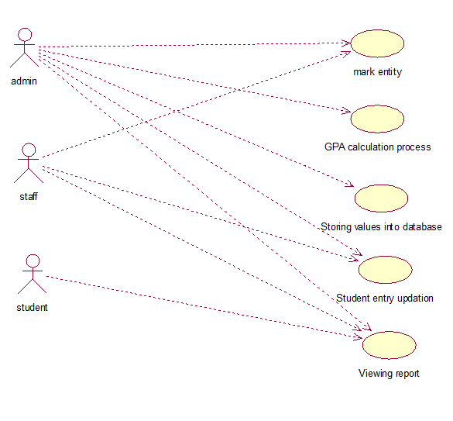

1. **Activity Diagram**

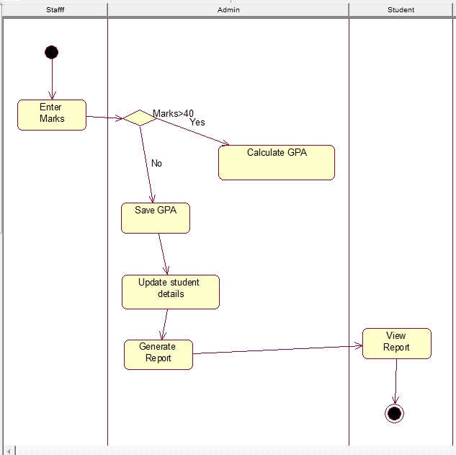

1. **Class Diagram**

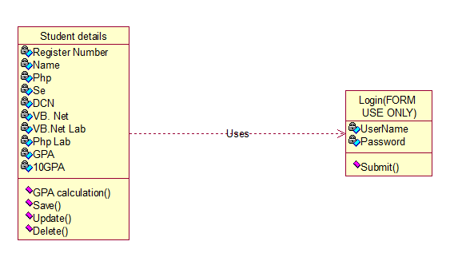

1. **Sequence Diagram**

#### Admin

Admin

login form

student details form

database

1.fill the login

2.submit

3.Check valid registration 4.Display error msg

5.Display home page

1. Student mark entry
2. Percentage Calculation

8.save

9.Student mark updation

10.update

11.Display student report

**Staff**

Staff

login form

student details form

database

1.fill the login

2.submit

3.Check valid registration 4.Display error msg

5.Display home page

6.Student mark entry

7.save

8.Student mark updation

9.update

10.Display student report

#### Student

Fill the login form

2. submit

3.Check valid registration

4.Display error message 5..Display home page

6.Display Report

database

login form

student

**Data Flow Diagram (DFD)**

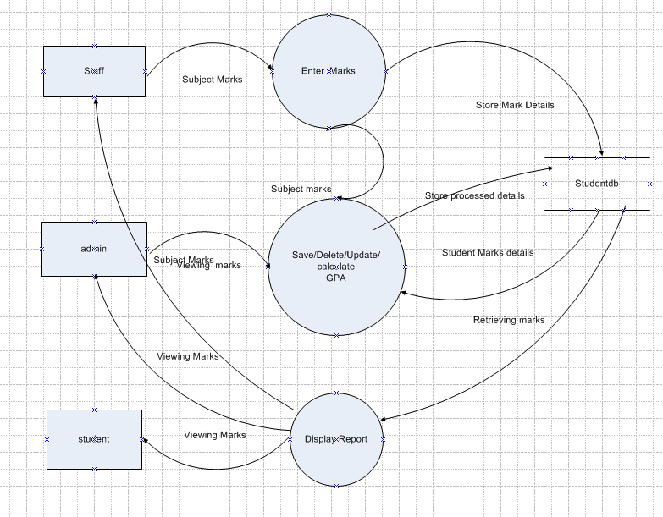

**Result :** Thus the UML diagrams such as Usecase Diagram, Class Diagram, Activity Diagram, Sequence diagram and Data Flow Diagram for Student mark Analysis System has been designed successfully.